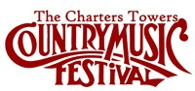
Contact
Festival Hotline: 0418 717 669
Email: ctcm@bigpond.com
Website: www.charterstowerscountrymusicfestival.com

Charters Towers Country Music Festival
________
Sponsorship Proposal Package 2020
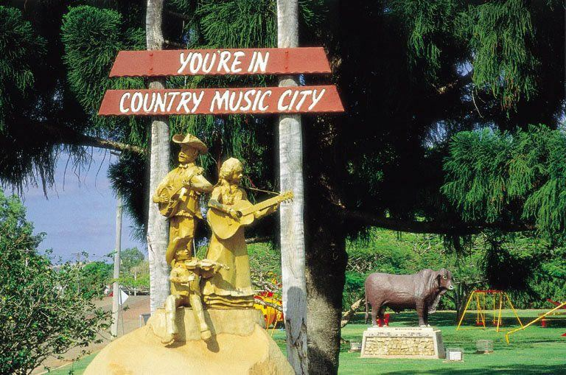
This proposal outlines an opportunity to partner your organisation with a major regional event unlike any other...

43rd annual Charters Towers Country Music Festival
1-3 May 2020

The Charters Towers Country Music Festival (CTCMF) was first held in 1977 to give the hard-working country folk of the region an opportunity to come together, put aside the daily grind of working on the land, sit back, relax and be entertained with a weekend of country music. Now, the Festival attracts a wide range of demographics and target markets, all of whom have one thing in common – a desire to hear great country music in a family-friendly festival atmosphere!
The past 6 years has seen the Festival undertake a massive facelift and experience necessary change with the aim to keep the rich tradition of the event continuing in the community of Charters Towers. The on-going drought in regional Queensland, the increasingly transient nature of the region and the aging population of Charters Towers has affected all volunteer-run events including CTCMF. Following extensive community consultation, in 2016, the Festival returned to its roots, combining venues to create one big, spirit-filled location - an event unlike any other in North Queensland.
CTCMF combines an amateur Talent Search held during the day, with 3 nights of quality professional toe-tapping music. Friday night at the Festival focusses a spotlight on local artists, seeking to raise awareness of the amazing talent the north of our great state has to offer. The Talent Search sees competitors travel from all over Australia to compete for the Overall winner prize package. Many contestants see the Talent Search as a stepping stone to becoming a professional performing artist. CTCMF is proud to acknowledge that some of Australia’s most popular artists have won the coveted Overall Award including, Samantha McClymont, Victoria Baillie, Brendon Walmsley and Judah Kelly. Saturday night is the key night of the event, offering a Showcase of incredible professional artists, including the Major Guest Artists.
Key Goals
The Charters Towers Country Music Festival Inc. has 3 Key Goals the drive the organisation of the event:

- To continue to offer a weekend of affordable country music entertainment
- Encourage visitors to our region
- Nurture creativity in the region by providing a ‘stage’ to showcase our talent
Demographic
In 2019, over 2,500 patrons attended the Festival throughout the weekend. The weekend caters to a mixed demographic, with the main target audience of the Friday night being families with adults aged 35-45 and older patrons aged 55+; Saturday night is aimed at a younger audience aged from 18-55; and, the Talent Quest Finals on Sunday night targeted at both families and older audiences. Camping facilities on site encourage a large number of ‘Grey Nomads’ to include the event in their travel itineraries for the cooler months of the year.
Sponsorship
There are different ways to support the Charters Towers Country Music Festival:
- Financial sponsorship
- Donation of products/services
- Volunteering

CTCMF relies on generous financial sponsorship to ensure the continued success of the event. Some of our financial sponsors have supported the Festival for a number of years, and we are always looking to engage with new companies to continually grow the Festival. Attractive benefit packages are available including exclusivity deals for maximum brand exposure. Details of our Financial Sponsorship can be found over the page.

The donation of goods/services can benefit CTCMF in a number of ways, including as Talent Search prizes, income-producing raffles and donation of goods/services required for the successful running of the event.

Volunteer positions exist in the lead up to the Festival, over the weekend, and during the pull-down of the Festival. Volunteers are given session passes to show appreciation for their time. Please contact the Committee to register your interest in volunteering over the Festival period.
Benefits of sponsoring the 2020 Charters Towers Country Music Festival
The key benefit of sponsoring the 2020 Charters Towers Country Music Festival is creating a partnership with a long-standing event, that will see your business gain exposure through print, radio and social media platforms. CTCMF has over 4000 followers on social media and this is a key method of communication with our patrons.
Financial Sponsorship at a Glance

SPONSORSHIP BENEFITS | SHOWCASE SPONSOR | MAJOR | DIAMOND | GOLD | SILVER | MATES | SUPPORTER
Naming rights to the Charters Towers Country Music Festival | ✗ | ✓ | ✗ | ✗ | ✗ | ✗ | ✗
Naming rights to the Charters Towers Country Music Saturday Night Showcase | ✓ | ✗ | ✗ | ✗ | ✗ | ✗ | ✗
Backstage access to meet Major Guest Artist/s* | ✓ | ✗ | ✗ | ✗ | ✗ | ✗ | ✗
Naming rights to sections: Adults, Junior, Juvenile, Duo/Group, Prince & Princess | ✗ | ✓ | ✗ | ✗ | ✗ | ✗ | ✗
Sponsor to present awards at Awards Night on Sunday night | ✗ | ✓ | ✗ | ✗ | ✗ | ✗ | ✗
Logo displayed on large advertising banner hung at prominent location in Charters Towers | ✓ | ✓ | ✗ | ✗ | ✗ | ✗ | ✗
Company logo to appear on print marketing material including official poster | ✓ | ✓ | ✗ | ✗ | ✗ | ✗ | ✗
Company logo to appear prominently on front cover of official program | ✓ | ✓ | ✗ | ✗ | ✗ | ✗ | ✗
Acknowledgement during the Saturday Night Showcase | ✓ | ✓ | ✗ | ✗ | ✗ | ✗ | ✗
Company name to be mentioned in print, media and radio advertising | ✓ | ✓ | ✓ | ✗ | ✗ | ✗ | ✗
Logo to appear on bottom of official poster | ✗ | ✗ | ✓ | ✓ | ✗ | ✗ | ✗
1/2 page of official program of events | ✓ | ✓ | ✓ | ✗ | ✗ | ✗ | ✗
1/4 page of official program of events | ✗ | ✗ | ✗ | ✓ | ✗ | ✗ | ✗
Logo and website link to appear on front of official website | ✓ | ✓ | ✓ | ✓ | ✗ | ✗ | ✗
Acknowledgement during the Awards Night | ✓ | ✓ | ✓ | ✓ | ✗ | ✗ | ✗
Company name mentioned regularly from Main Stage throughout weekend | ✓ | ✓ | ✓ | ✓ | ✓ | ✓ | ✓
Company banners to be displayed | ✓ | ✓ | ✓ | ✓ | ✓ | ✓ | ✓
Logo to appear in sponsors section on official website | ✓ | ✓ | ✓ | ✓ | ✓ | ✓ | ✓
Company logo to appear on sponsors page of official program of events | ✓ | ✓ | ✓ | ✓ | ✓ | ✓ | ✓
V.I.P. Weekend Passes | 6 | 5 | 4 | 3 | 2 | 1 | 0

*Depending on Major Guest Artist’s terms of contract
Financial Sponsorship in Detail
SHOWCASE SPONSOR | $15,000+ | - Naming rights to the Charters Towers Country Music Saturday Night Showcase  - Backstage access to meet Major Guest Artist/s*  - Logo displayed on large advertising banner hung at prominent location in Charters Towers  - Company logo to appear on print marketing material including official poster  - Company logo to appear prominently on front cover of official program  - Acknowledgement during the Saturday Night Showcase  - Company name to be mentioned in print, media and radio advertising  - 1/2 page of official program of events  - Logo and website link to appear on front of official website  - Acknowledgement during the Awards Night  - Company name mentioned regularly from Main Stage throughout weekend  - Company banners to be displayed  - Logo to appear in sponsors section on official website  - Company logo to appear on sponsors page of official program of events | 6 V.I.P Weekend Passes
MAJOR | $14,999 - $10,000 | - Naming rights to the Charters Towers Country Music Festival  - Naming rights to sections: Adults, Junior, Juvenile, Duo/Group, Prince & Princess  - Sponsor to present awards at Awards Night on Sunday night  - Logo displayed on large advertising banner hung at prominent location in Charters Towers  - Company logo to appear on print marketing material including official poster  - Company logo to appear prominently on front cover of official program  - Acknowledgement during the Saturday Night Showcase  - Company name to be mentioned in print, media and radio advertising  - 1/2 page of official program of events  - Logo and website link to appear on front of official website  - Acknowledgement during the Awards Night  - Company name mentioned regularly from Main Stage throughout weekend  - Company banners to be displayed  - Logo to appear in sponsors section on official website  - Company logo to appear on sponsors page of official program of events | 5 V.I.P Weekend Passes
DIAMOND | $9,999 - $5,000 | - Company name to be mentioned in print, media and radio advertising  - Logo to appear on bottom of official poster  - 1/2 page of official program of events  - Logo and website link to appear on front of official website  - Acknowledgement during the Awards Night  - Company name mentioned regularly from Main Stage throughout weekend  - Company banners to be displayed  - Logo to appear in sponsors section on official website  - Company logo to appear on sponsors page of official program of events | 4 V.I.P Weekend Passes
GOLD | $4999 - $2,501 | - Logo to appear on bottom of official poster  - 1/4 page of official program of events  - Logo and website link to appear on front of official website  - Acknowledgement during the Awards Night  - Company name mentioned regularly from Main Stage throughout weekend  - Company banners to be displayed  - Logo to appear in sponsors section on official website  - Company logo to appear on sponsors page of official program of events | 3 V.I.P Weekend Passes
SILVER | $2,500 - $1,001 | - Company name mentioned regularly from Main Stage throughout weekend  - Company banners to be displayed  - Logo to appear in sponsors section on official website  - Company logo to appear on sponsors page of official program of events | 2 V.I.P Weekend Passes
MATES | $1,000 - $500 | - Company name mentioned regularly from Main Stage throughout weekend  - Company banners to be displayed  - Logo to appear in sponsors section on official website  - Company logo to appear on sponsors page of official program of events | 1 V.I.P Weekend Pass
SUPPORTER | Up to $499 | - Company name mentioned regularly from Main Stage throughout weekend  - Company banners to be displayed  - Logo to appear in sponsors section on official website  - Company logo to appear on sponsors page of official program of events

Official Agreement
This is a sponsorship agreement between:
Charters Towers Country Music Inc. AND
Sponsor | Company Name
Term of Sponsorship
- 1 Year
- 2 Years
- 3 Years
- 4 Years
- 5 Years
Level of Sponsorship
- Showcase Sponsor
- Major Sponsor
- Diamond Sponsor
- Gold Sponsor
- Silver Sponsor
- Mates Sponsor
- Supporter Sponsor

Signed for on behalf of the Sponsor by an authorized representative:

Representative Name: Date:

Charters Towers Country Music Festival Representative signature:

Representative Name: Date:

Invoice Available Upon Request
Direct Deposit Details:
Account BSB: 704 640
Account Number: 41425319
(Please use Company Name as Reference)

Or make cheque payable to:
Charters Towers Country Music Inc.
PO Box 20
Charters Towers Qld 4820

